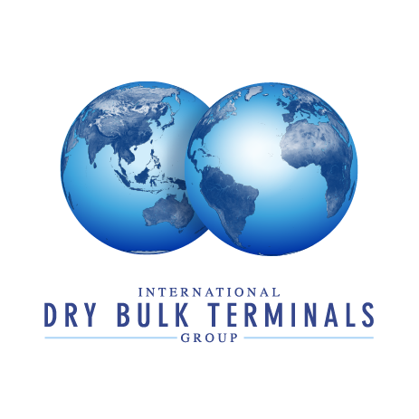

**DBTG Operational and Technical Meeting 2017, Punta del Este, Uruguay.**

**Wednesday 8th November**

|  |  |
| --- | --- |
| 1830 - 2030 | Registration and Welcome Drinks Reception. |

**Thursday 9th November – Day One**

|  |  |
| --- | --- |
| 0815 - 0900 | Coffee and Conversation |
| 0900 - 0930 | **DBTG Issues and Developments**  The meeting will be opened by the Chairman of DBTG Han Ozturk and  the Executive Director Nic Ingle. Nic will briefly update Members on his  activities since the April meeting in Gijon.  Presenters: Han Ozturk and Nic Ingle |
| 0930 – 1030 | **Regulatory Update**  **Nic Ingle**. The Global Bauxite Working Group, established by the IMO in  2016, reported the findings of their research to the September meeting  of the 4th Carriage of Cargoes and Containers (CCC4) session at the  IMO. This session will provide a detailed overview of that research.  It will also update Members on the Ballast Water Management  Convention (BWM) and the Hazardous Dust issue cover in April.  Discussion on the presentations to include Members experience and  concerns. |
| 1030 - 1100 | Coffee |
| 1100 - 1200  1200 - 1230 | **Operational challenge session**  Presenters:  **Paul MacGillivary**. Paul is the Project Lead – Marine Safety at Associate  Member RightShip. He is currently running a project aimed at the dry bulk  industry, to provide a guide called the International Safety Guide for Bulk  Carriers and Terminals (ISGBCT). This is based on the now standard oil  industry document, the International Safety Guide for Oil Tankers and  Terminals (ISGOTT). In this session Paul will introduce you to the  concept.  **Shaun Sears**. Shaun is the General Nanager of Operations at Port  Waratah Coal Services in Australia. In this session he will discuss the Port  Waratah approach to the Ship to Shore interface.  **Ryan Olson**. Ryan is the Director of Operations at our partner  organisation NAEGA and will brief the group on USA trade policy  developments.  Discussion on the presentations to include Members involvement where applicable. |
| 1230 - 1330 | Buffet Lunch – Conrad Hotel |
| 1330 - 1430  1430-1530  1530 - 1600  1600 – 1700 | Business Development/Terminal Expansion  Presenter:  **John LaRue**. John is the Executive Director of Port Corpus Christi.  In this session John will detail the master planning and resulting  dock upgrades including a new crane purchase at Port Corpus  Christi.  **Chris Leonard**. Chris is the Business Development Director at  Nectar and will be talking about the phase 2 development of the  Nectar terminal in the Philippines  **Technical Challenges Session**  Presenter:  **John LaRue**. In this session John will detail the challenges that  Port Corpus Christi faced following the damage caused by storm  Harvey.  **Steve Yee**. Steve is the Vice President of Associate Member CWA  Engineers Inc. and will discuss the advantages and disadvantages  of planned maintenance at a terminal versus replacement of equipment  Coffee  **Cargo Challenges Session**  **Andrés Gómez Bueno**. Andrés is the Director General of Gof S.A.  as well as an Executive Committee Member of DBTG. In this  session he will look at dust suppression and the value it can add  to the process on grains.  **Gene Taft**. Gene is the CEO of Summit Marine, An Executive  Committee Member of DBTG and a distiller of fine Bourbon. Today  he will highlight the Effects of Terminal Dust Control on Petroleum  Coke Moistures. |
|  |  |

**Friday 10th November – Day Two**

|  |  |
| --- | --- |
| 0815 - 0900 | Coffee and Conversation |
| 0900 - 1000  1000 - 1030 | **Health and Safety Session**  Presenters:  **Sjaak Stengs**. Sjaak is the Managing Director of Rietlanden Terminals in  Amsterdam. Sjaak has kindly agreed to share the impact a fatal  accident had on the company.  **Shaun Sears**. Shaun is the General Manager of Operations at Port  Waratah Coal Services in Australia. In this session, he will outline some o  of the Health and Safety issues experienced at his terminal  **Freight and Commodity Market Developments**  **Nic Ingle**. Susan Oatway, an associate at Drewry is unable to attend but  has provided a presentation for Nic to deliver – no tricky questions please.  Discussion on the presentations to include Members experience where  applicable. |
| 1030 - 1100 | Coffee |
| 1100 - 1200 | Facilitator: Han Ozturk, DBTG Chairman  **Nic Ingle**. Nic will outline the plans for the next meeting in April 2018.  Final open discussion on any of the presentations seen.  Next meeting and closing remarks |
| 1200 - 1300 | Buffet Lunch – Conrad Hotel |
| 1300 - 1515  1515 – 1700  1700 - 1930  1930 | Depart for terminal tour  The transport to the terminal in Montevideo will depart at 1315, you  are reminded to ensure that you wear suitable footwear (no open  shoes or sandals). All other PPE will be provided by TGM.  For those that are not returning to the Conrad after the tour, please  ensure that you have checked out of the hotel.  Terminal Tour – TGM Grain terminal, Montevideo  The tour will take 1.5 to 2 hours.  The coach will drop anyone off at the airport before returning to Punta  del Este.  Close |